**Tutorial #7**

**Cloud Security INTE2401/2402**

**1. Multiple Choice Question**

(1) Techniques for distribution of public keys include _______________.

A. public announcement

B. public directory

C. public certificate

D. A, B and C

(2) X.509 certificates are signed by __________________.

A. subject

B. issuer

C. either A or B

D. both A and B

(3) X.509 certificates are used to certify _______________

A. public keys of users

B. private keys of users

C. public keys of issuer

D. private keys of issuer

(4) __________ is an integer value unique within the issuing CA that is unambiguously associated with this certificate.

A. Signature identifier

B. Version

C. Serial number

D. Issuer unique identifier

(5) Secure Socket Layer (SSL) protects communication between client and server at

A. Application Layer

B. Transport Layer

C. Internet Layer

D. Link Layer

(6). When initiating SSL session, the client and the server establish a connection through TCP port

A. 21 ssh

B. 80 http

C. 443 https

D. None of the above

(7). In SSL, a protocol for initial authentication and transfer of encryption keys, is called

A. Handshake protocol

B. Authentication protocol

C. Record protocol

D. Cipher protocol

(8) In SSL, a session ID has

A. 16 bytes

B. 32 bytes

C. 48 bytes

D. 64 bytes

(9) The pre-master-key in SSL has

A. 16 bytes

B. 32 bytes

C. 48 bytes

D. 64 bytes

(10) In SSL, the random number chosen by the client has

A. 16 bytes

B. 32 bytes

C. 48 bytes

D. 64 bytes

**2. Conceptual and Computational Questions**

(1) A public key certificate is an electronic document used to prove the ownership of a public key. Download the public key certificate of Apple Root CA from https://www.apple.com/certificateauthority/ and install. In Apply Root CA certificate,

1. What is the subject?
2. What is the issuer?
3. What is the public key of the subject?
4. What is the digital signature algorithm to be used to sign the certificate?
5. What is the expiry date of this certificate?
6. What is the public key to be used to certify the certificate?
7. What is the issuer’s signature on this certificate?
8. What is the hash value of the certified content of this certificate?

(2) Secure Sockets Layer (SSL) is a networking protocol designed for securing connections between web clients and web servers over an insecure network, such as the internet. SSL includes handshake protocol and record protocol. Describe SSL handshake protocol with server authentication.

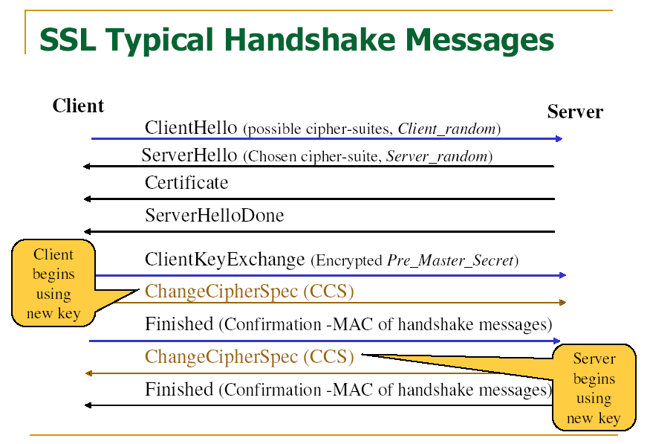

**3. Programming (HTML and JavaScript) Questions**

(1) Install Openssl (<https://www.openssl.org/>) and verify Apple Root Certificate.

1. Retrieve the public key from the Apply Root Certificate;
2. Get signature from the Apply Root Certificate;
3. Get decrypted signature
4. Extract the certificate body
5. Hash certificate body
6. Verify the signature of the certificate

(2)getaCert (<https://getacert.com/selfsignedcert.html>) is a Certificate Authority to issue Self-Signed certificate online. With getaCert, create your Self-Signed certificate and verify the certificate.